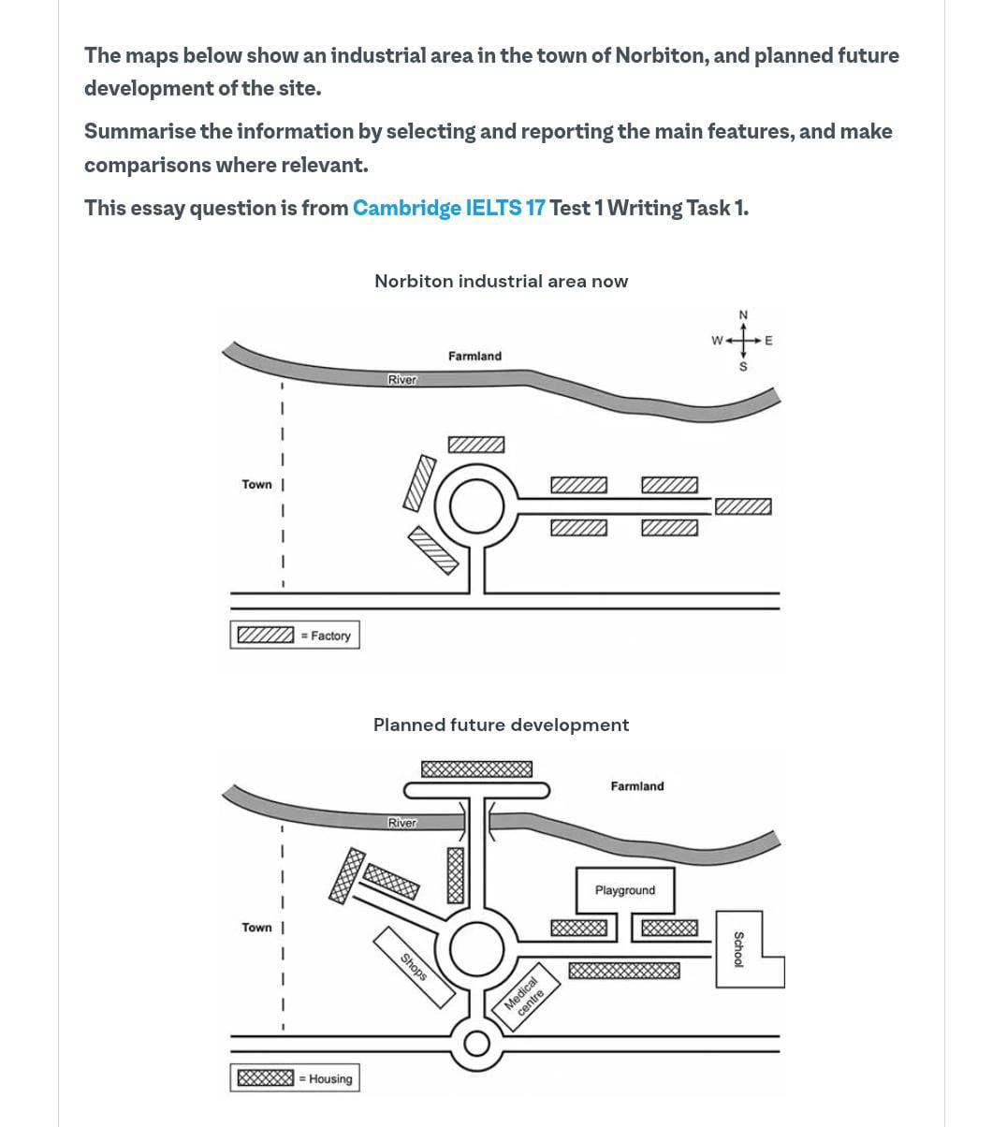
Band = 8.5
The provided maps illustrate the transformation of the industrial area in Norbiton into a planned future housing society.
Overall, it is evident that while the present site is dominated by factories and industrial buildings, in the future it will be redeveloped into a well-organized residential community with essential facilities such as a school, playground, medical centre, and shopping area. Additionally, the factories will be relocated to the outskirts of the town.
A detailed observation indicates that the current industrial area consists of around twelve factories located along a ring road in the center of the town, with a few scattered residential houses on both sides of the eastern link road. The river flows in the north, the main road lies to the south, and the existing town where residents currently live is situated to the west.
In the future, the overall skeleton of the town will remain unchanged; however, significant infrastructure improvements are planned. Several new roads and a bridge across the river will connect farmland to the housing area. The industrial units will be replaced with housing blocks, while key facilities including a school, playground, medical centre, and shops will be constructed at different junctions within the residential layout.

